Arduino Board: Uno
Arduino UNO is a microcontroller board based on the ATmega328P. It has 14 digital input/output pins (of which 6 can be used as PWM outputs), 6 analog inputs, a 16 MHz ceramic resonator, a USB connection, a power jack, an ICSP header and a reset button. It contains everything needed to support the microcontroller; simply connect it to a computer with a USB cable or power it with a AC-to-DC adapter or battery to get started.
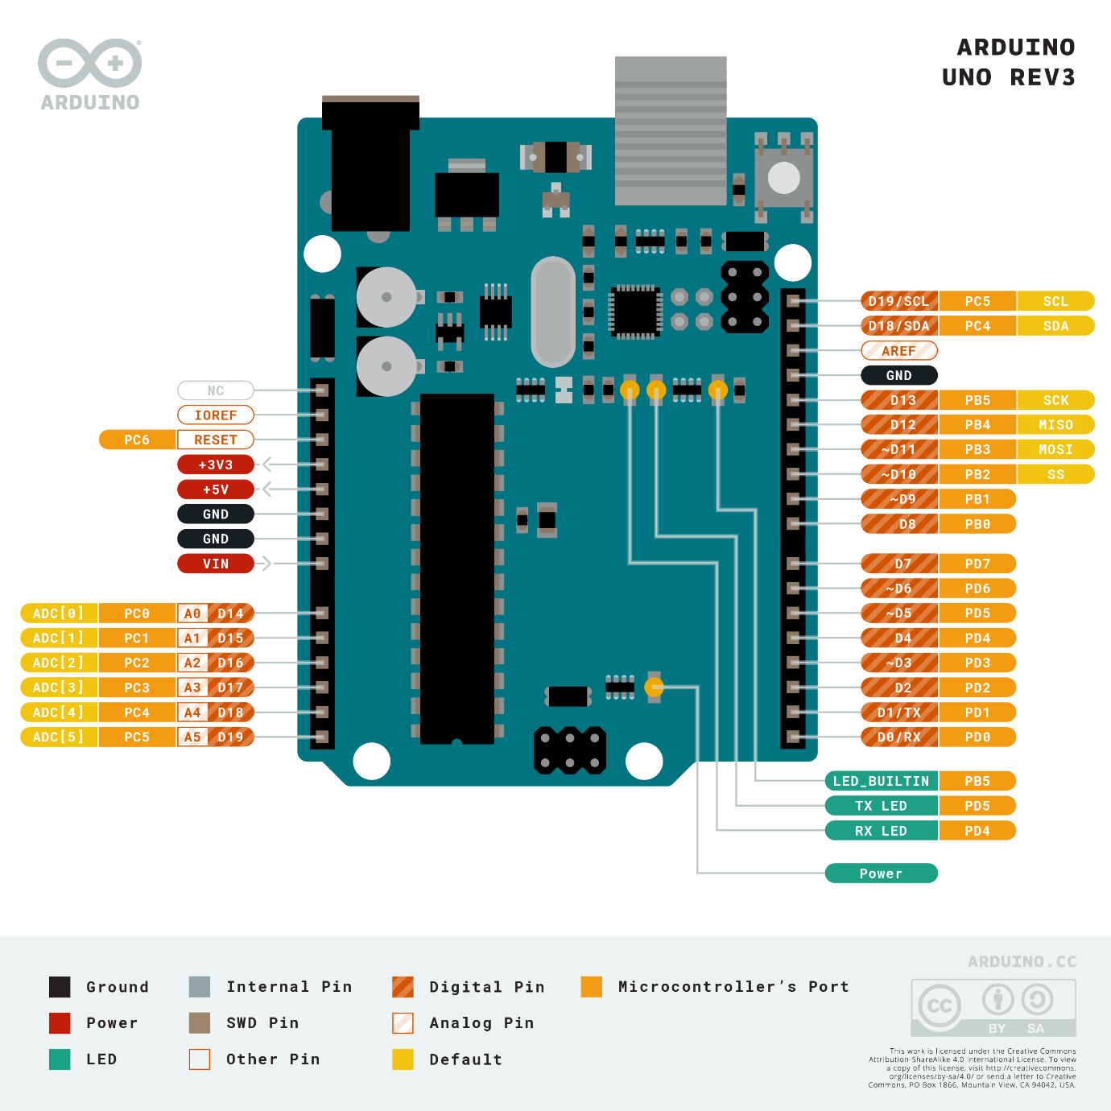

Arduino Board: Nano RP2040 Connect
The Arduino® Nano RP2040 Connect is a development board in Nano format, based on the RP2040 microcontroller. It features a Wi-Fi / Bluetooth® module, a 6-axis IMU (Inertial Measurement Unit) with machine learning capabilities, a microphone and a built-in RGB.

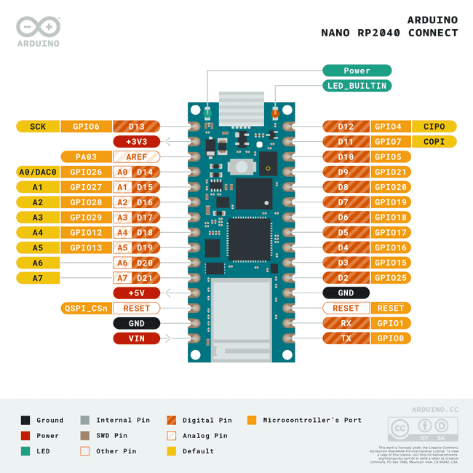

Arduino Integrated Development Environment
Can be downloaded from https://www.arduino.cc/en/software
For windows download zip file here:
https://downloads.arduino.cc/arduino-ide/arduino-ide_2.0.4_Windows_64bit.zip
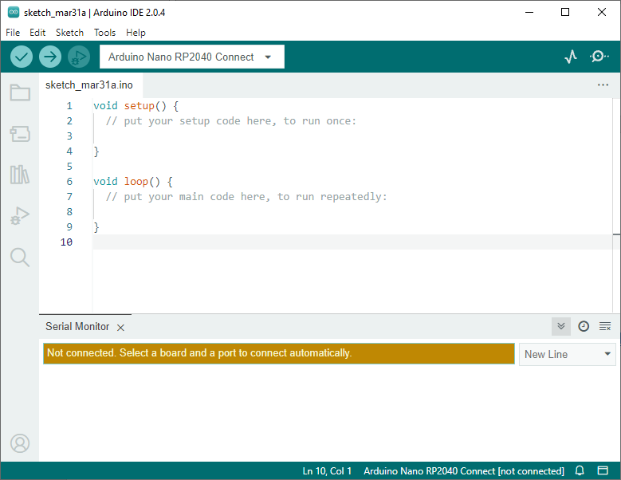
The main code is written in C and has two main functions setup and loop:
void setup(){
// put your setup code here, to run once:
Serial.begin(9600);
}

void loop(){
// put your main code here, to run repeatedly:
Serial.println("Hello World!");
delay(500);
}

Once code is written, the board should be connected to the PC using USB. Correct type of the board should be selected and it can be uploaded to the board. The results send by the board to the PC using Serial.println can be viewed in serial monitor.

Task 1: Inertial Measurement Unit (IMU) data acquisition
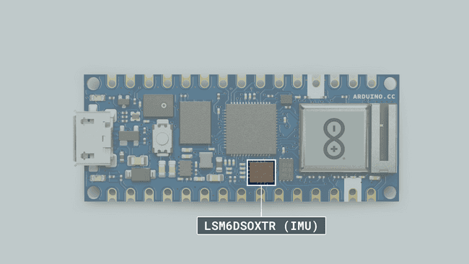

LSM6DSOXTR
The LSM6DSOXTR from STM is an IMU (Inertial Measurement Unit) that features a 3D digital accelerometer and a 3D digital gyroscope. It features among many other things, a machine learning core, which is useful for any motion detection projects, such as free fall, step detector, step counter, pedometer.
This module also features an embedded temperature sensor.

LSM6DSOX Library
To access the data from the LSM6DSOX module, we need to install the LSM6DSOX library, which comes with examples that can be used directly with the Nano RP2040 Connect.
It can be installed directly from the library manager through the IDE of your choice. To use it, we need to include at the top of the sketch:
#include <Arduino_LSM6DSOX.h>
And to initialize the library, we can use the following command inside
void setup()
.
if (!IMU.begin()) {
Serial.println("Failed to initialize IMU!");
while (1);
}

Accelerometer
The accelerometer data can be accessed through the following commands:
float x, y, z;

if (IMU.accelerationAvailable()) {
IMU.readAcceleration(x, y, z);
}

Gyroscope
The gyroscope data can be accessed through the following commands:
float x, y, z;

if (IMU.gyroscopeAvailable()) {
IMU.readGyroscope(x, y, z);
}

Temperature
The temperature data can be accessed through the following code:
if (IMU.temperatureAvailable())
{
int temperature_deg = 0;
IMU.readTemperature(temperature_deg);

Serial.print("LSM6DSOX Temperature = ");
Serial.print(temperature_deg);
Serial.println(" °C");
}

Steps:
- Install Arduino IDE
- Inside Arduino IDE use board manager search for " Nano RP2040 Connect" and install Arduino Mbed OS Nano Boards.
- In the Library Manager search for " LSM6DSOX" and Install Arduino_ LSM6DSOX.
- Create the new sketch and write the code using the snipsets above to collect the data from the accelerometer, gyroscope and temperature sensors.
- Send the data to the serial port monitor and copy it to a text file.
- Access the maximum frequency of the data updates that you can achieve with this sensor (modify the delay(500); function in line 62).

Task 2: Serial port communication latency
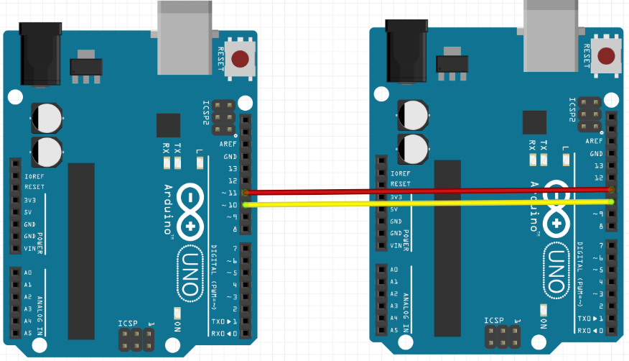
Boards connection diagram
To measure the latency of the communication through the serial port, send one byte message from one Arduino to another one and then send it back to the first one again. Use SoftwareSerial function. Measure the time it take for this very simple message to travel both ways using the function micros() that can measure microseconds.
Example of the code for sender and receiver boards:
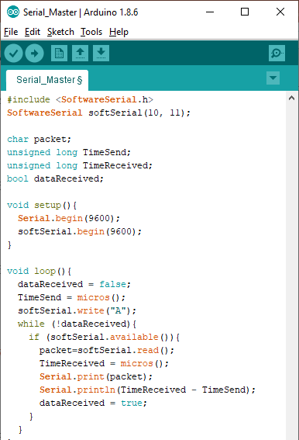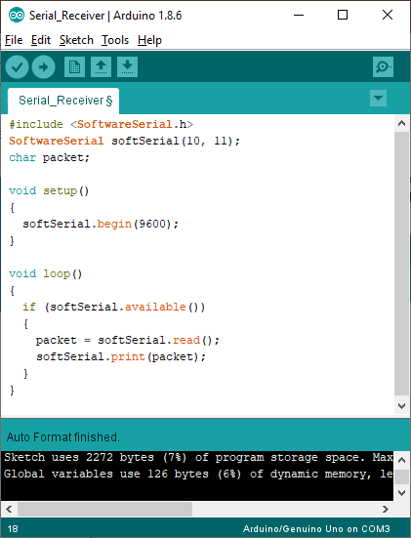
Steps:
- Connect two boards according to the diagram (pins 10 and 11)
- Copy the code to two seprate Arduino IDE
- Upload the code to both arduino and measure the latency in serial port monitor.
- Change the seial speed from 9600 to 115200 and check how much faster it works.
Task 3: Measure the latency of the signal travelling on the Enternet network

The latency of the signal travelling through the internet connection can be much longer that on local serial port.
To measure it use the shell fuction ping:

ping 81.99.6.43
ping google.fr
ping google.co.uk
ping google.com
Test any other websites of companies you can think of.

You can do it using MobaXterm
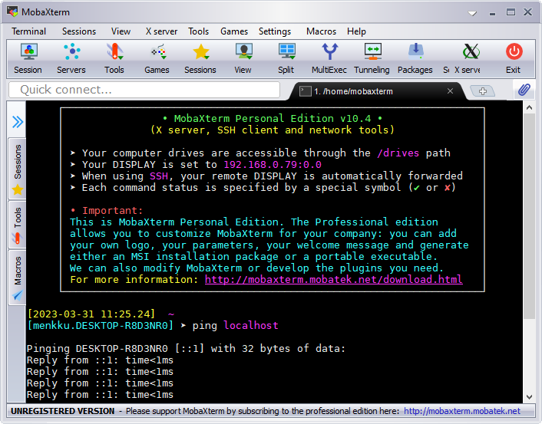

It can be downloaded from: https://mobaxterm.mobatek.net

Direc link: https://download.mobatek.net/2302023012231703/MobaXterm_Portable_v23.0.zip

Steps:
- Download MobaXter and unzip it. Start the MobaXterm.exe program.
- Enter the ping fuction for different domains and record the shortest and the longest replay times.

Task 4: Measure the distance using Ultrasound sensor

Ultrasound sensor HC-SR04 Overview
The HC-SR04 is an affordable and easy to use distance measuring sensor which has a range from 2cm to 400cm. The sensor is composed of two ultrasonic transducers. One is transmitter which outputs ultrasonic sound pulses and the other is receiver which listens for reflected waves. It’s basically a SONAR.
Here are its main specifications:
Operating Voltage | 5V DC
Operating Current | 15mA
Operating Frequency | 40KHz
Min Range | 2cm
Max Range | 400cm
Accuracy | 3mm
Measuring Angle | <15°
Dimension | 45 x 20 x 15mm

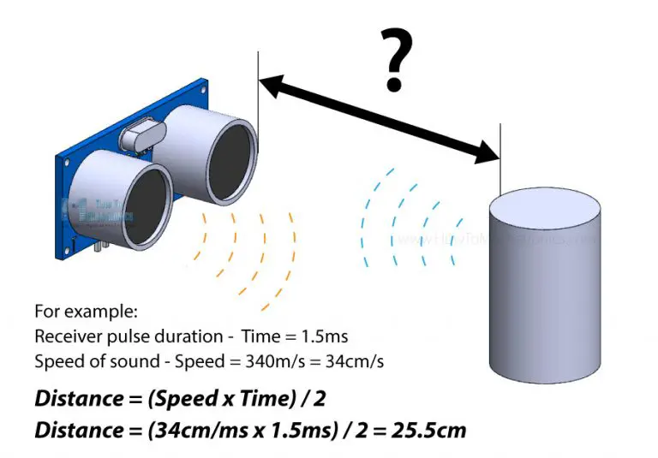
Distance = (Speed x Time) / 2 = (34cm/ms x 1.5ms) / 2 = 25.5cm.

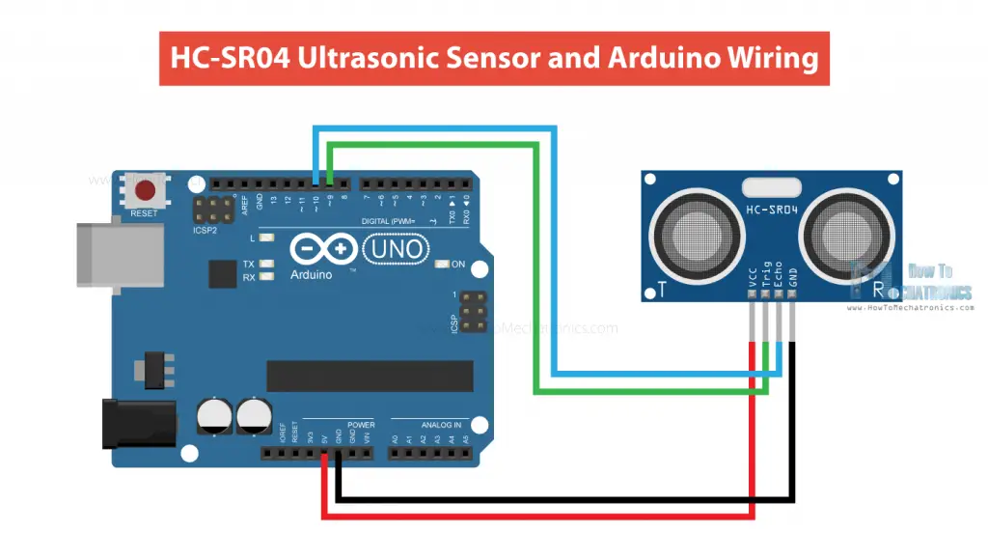
Check how many mesurement per second you can achive when object is close and how many if it is further away.

Example of the code:

// defines pins numbers
const int trigPin = 9;
const int echoPin = 10;

// defines variables
long duration;
int distance;

void setup() {
pinMode(trigPin, OUTPUT); // Sets the trigPin as an Output
pinMode(echoPin, INPUT); // Sets the echoPin as an Input
Serial.begin(9600); // Starts the serial communication
}

void loop() {
// Clears the trigPin
digitalWrite(trigPin, LOW);
delayMicroseconds(2);

// Sets the trigPin on HIGH state for 10 micro seconds
digitalWrite(trigPin, HIGH);
delayMicroseconds(10);
digitalWrite(trigPin, LOW);

// Reads the echoPin, returns the sound wave travel time in microseconds
duration = pulseIn(echoPin, HIGH);

// Calculating the distance
distance = duration * 0.034 / 2;

// Prints the distance on the Serial Monitor
Serial.print("Distance: ");
Serial.println(distance);
}

Steps:
- Connect the ultrasonic sensor to the Arduino Uno board following the diagram above.
- Upload the code to the arduino uno board and open the serial port monitor
- Check that the distance measured is correct using the measuring tape.
- Check the accuracy as a function of the distance
- Evaluate the effect of the object shape on the distance measurement accuracy.

Task 5: CAN BUS communication with MCP2515 Controller

The MCP2515 CAN Bus Controller is a simple Module that supports CAN Protocol version 2.0B and can be used for communication at 1Mbps. In order to setup a complete communication system, you will need two CAN Bus Module.

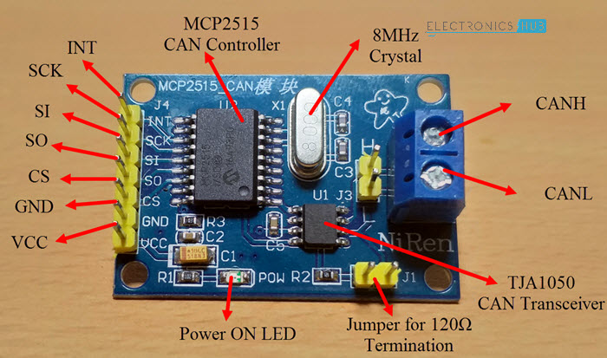
Can Bus Controller

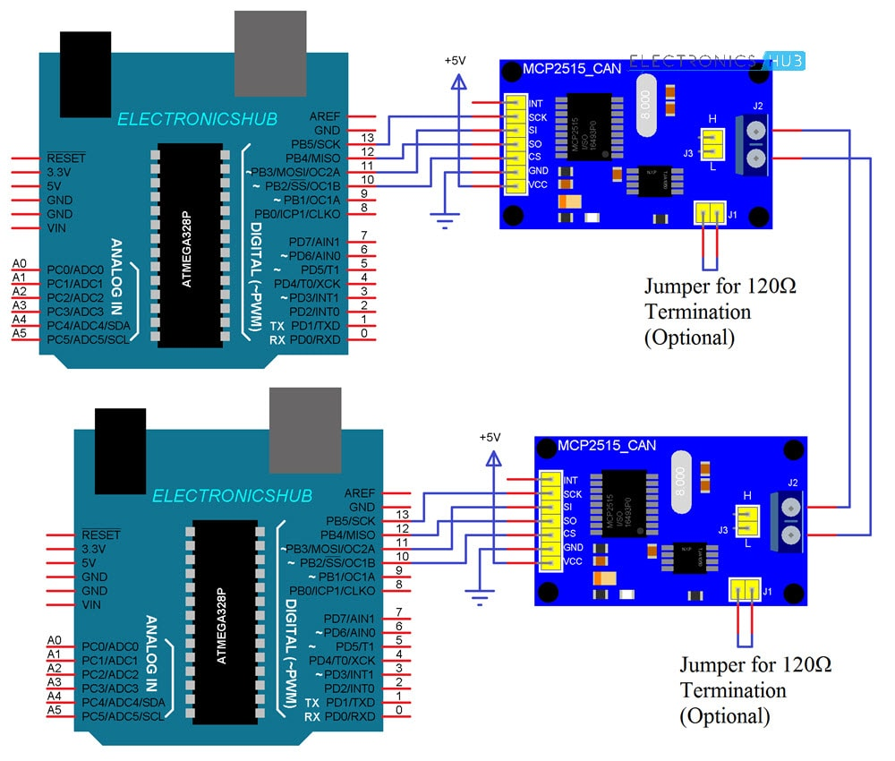
Circuit diagram of interfacing MCP2515 CAN Module with Arduino and possible communication between two Arduino over CAN Protocol.

Code Example Transmitter:
#include <SPI.h>
#include <mcp_can.h>

const int spiCSPin = 10;
int ledHIGH = 1;
int ledLOW = 0;

MCP_CAN CAN(spiCSPin);

void setup() {
Serial.begin(115200);

while (CAN_OK != CAN.begin(CAN_500KBPS)) {
Serial.println("CAN BUS init Failed");
delay(100);
}
Serial.println("CAN BUS Shield Init OK!");
}

unsigned char stmp[8] = { ledHIGH, 1, 2, 3, ledLOW, 5, 6, 7 };

void loop() {
Serial.println("In loop");
CAN.sendMsgBuf(0x43, 0, 8, stmp);
delay(1000);
}

Code Example Receiver:
#include <SPI.h>
#include "mcp_can.h"

const int spiCSPin = 10;
const int ledPin = 2;
boolean ledON = 1;

MCP_CAN CAN(spiCSPin);

void setup() {
Serial.begin(115200);
pinMode(ledPin, OUTPUT);

while (CAN_OK != CAN.begin(CAN_500KBPS)) {
Serial.println("CAN BUS Init Failed");
delay(100);
}
Serial.println("CAN BUS Init OK!");
}

void loop() {
unsigned char len = 0;
unsigned char buf[8];

if (CAN_MSGAVAIL == CAN.checkReceive()) {
CAN.readMsgBuf(&len, buf);

unsigned long canId = CAN.getCanId();

Serial.println("-----------------------------");
Serial.print("Data from ID: 0x");
Serial.println(canId, HEX);

for (int i = 0; i < len; i++) {
Serial.print(buf[i]);
Serial.print("\t");
if (ledON && i == 0) {

digitalWrite(ledPin, buf[i]);
ledON = 0;
delay(500);
} else if ((!(ledON)) && i == 4) {

digitalWrite(ledPin, buf[i]);
ledON = 1;
}
}
Serial.println();
}
}

Steps:
- Using library manager in Arduino IDE install "mcp_can by coryjfowler"
- Connect the arduino boards with MCP2515 CAN Bus Controller using jumps wires
- Connect two MCP2515 CAN Bus Controller between eachother using two wires
- Upload the code to transsiver and receiver boards
- Open serial monitor in the receiver and check that the correct message was received.
- Modify the code to measure the latency and message travel time using micros() function, see serial port code in Task 1.

Task 6: CAN BUS communication with Arduino Due Board
Install the libraries for Arduino Due board.  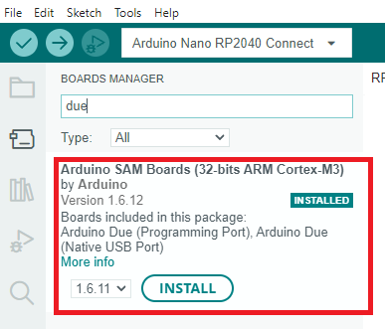 | Install libraries for due_can  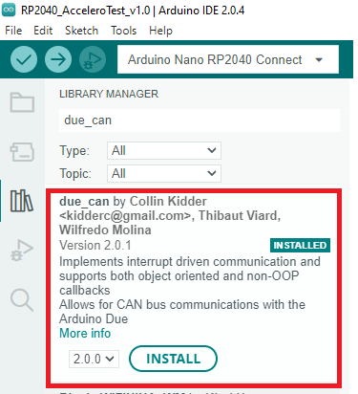

Open example codes from:
File / Examples / due_can / CAN_EchoTest
File / Examples / due_can / CAN_ExtendedPingPong
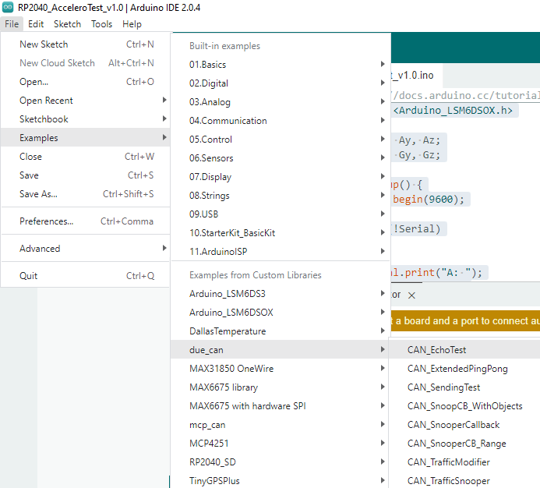
The following image shows the available CAN port connections:
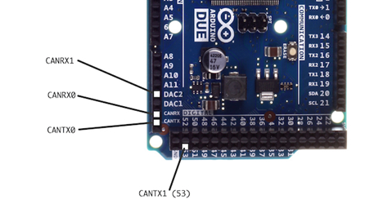
Connect using jumper wires:
CAN_TX_0 ------------------------ CAN_TX_1
CAN_RX_0 ------------------------ CAN_RX_1

Connect Arduino Due with computer using USB Programming Port and select the Arduino Due board and serial port:
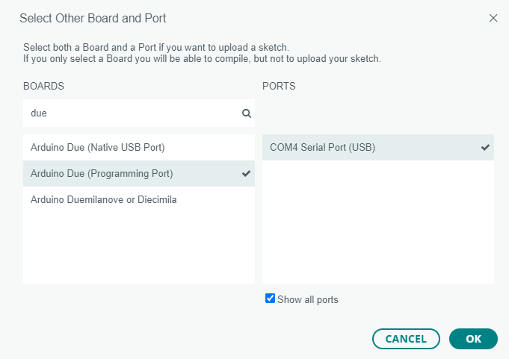

In the code comment line 22:
Compile the code and upload it to the board.
Go to the Serial Monitor and try to send an Integer number from CAN0 to CAN1.
Task 7: GPS MODULE (USB) Arduino Serial Monitor
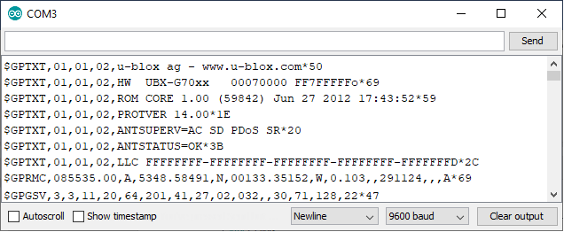

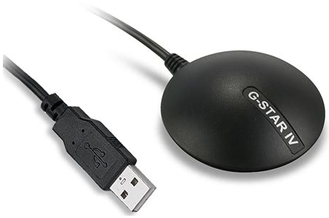
NO SIGNAL:
$GPRMC,084214.00,V,,,,,,,291124,,,N*7B
$GPVTG,,,,,,,,,N*30
$GPGGA,084214.00,,,,,0,00,99.99,,,,,,*6D
$GPGSA,A,1,,,,,,,,,,,,,99.99,99.99,99.99*30
$GPGSV,1,1,03,09,,,12,11,,,24,20,,,30*77
$GPGLL,,,,,084214.00,V,N*41

SIGNAL CORRECT:
$GPRMC,085025.00,A,5348.58474,N,00133.35731,W,0.727,,291124,,,A*65
$GPVTG,,T,,M,0.727,N,1.347,K,A*20
$GPGGA,085025.00,5348.58474,N,00133.35731,W,1,04,9.11,111.5,M,47.8,M,,*44
$GPGSA,A,3,13,11,05,20,,,,,,,,,13.26,9.11,9.63*34
$GPGSV,3,1,11,05,59,288,30,07,49,066,20,09,13,088,,11,21,212,33*72
$GPGSV,3,2,11,13,39,263,37,15,,,31,16,00,010,,18,11,332,*48
$GPGSV,3,3,11,20,66,204,41,27,01,034,,30,70,136,23*4A
$GPGLL,5348.58474,N,00133.35731,W,085025.00,A,A*73

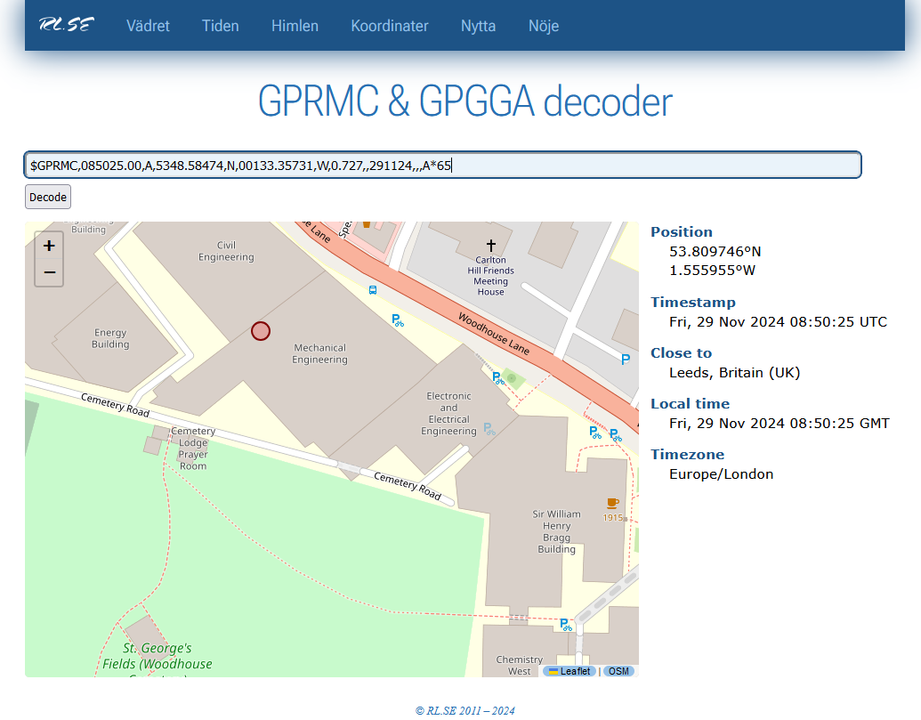
More information at:
https://rl.se/gprmc
https://aprs.gids.nl/nmea

